# TC2XX&TC3XX_MotherBoard_焊接说明

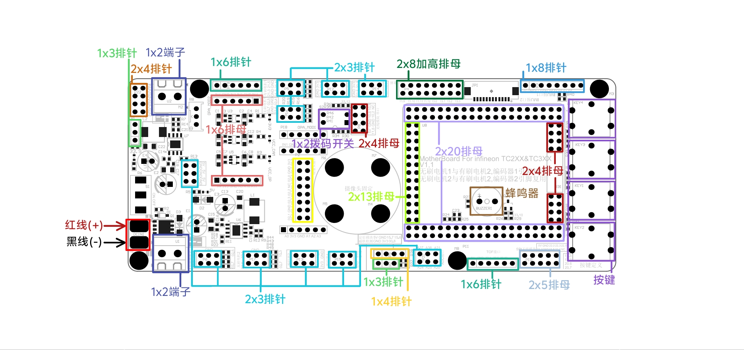

|  |  |  |
| --- | --- | --- |
| 元件 | 数量 | 备注 |
| **1x3P排针** | 2 |  |
| **1x4P排针** | 1 |  |
| **1x6P排针** | 2 |  |
| **1x8P排针** | 1 |  |
| **2x3P排针** | 10 |  |
| **2x4P排针** | 1 |  |
| **1x6P排母** | 2 |  |
| **2x4P排母** | 3 |  |
| **2x5P排母** | 1 |  |
| **2x8P排母** | 1 |  |
| **2x13P排母** | 1 |  |
| **2x20P排母** | 2 |  |
| **2x8P加高排母** | 1 |  |
| **1x2P端子** | 2 |  |
| **1x2P拨码开关** | 1 |  |
| **按键** | 4 |  |
| **蜂鸣器** | 1 |  |
| **电源线** | 1 | 注意正负极不要焊反！ |